EASTER HOLIDAY TIMETABLE
To book please visit or contact:

1 Scott Skinner Square
Banchory
AB31 5SE
07871 573194
numberonebanchory@gmail.com

Mon 3rd | Deeside First Responders  Defibrillator familiarisation  Drop in session  10am-12pm | Mon 10th | Deeside First Responders  Defibrillator familiarisation  Drop in session  10am-12pm
Tue 4th | Deeside First Responders  Defibrillator familiarisation  Public drop in session  2pm-4pm  Bring your own Sewing  2.30pm-3.30pm  £1pp | Tue 11th | Storytelling Fun with Pauline Cordiner  Age 5-8, 9.30am-11am  Age 9-12, 11.30am-1.30pm  £5per child  Deeside First Responders  Defibrillator familiarisation  Public drop in session  2pm-4pm  Bring your own Sewing  2.30pm-3.30pm, £1pp
Wed 5th | Lottie's Lockets  Stretch Bracelet Class  10am-12pm  5-7yo  £15pp (includes snack) | Wed 12th | Lottie's Lockets  Charm Bracelet Class  10am-12pm  10+yo  £20pp (includes snack)
Thurs  6th | Deirdry Varley Illustration Workshops  Child 10am-11am  Teens 1pm-2pm  £5pp  (please bring a A3 pad of paper) | Thurs  13th | Youth Showcase  Visit local youth groups and find out what they have been up to and how you can get involved.  FREE ENTRY  11am-4pm
Fri 7th | Meet the Author and storytelling with Brian Chambers  1pm-2.30pm  FREE ENTRY  Friday Night Youth Drop In  5pm-9pm | Fri 14th | Usborne Book Party  FREE ENTRY  2pm-4pm  (You can spend your World Book Tokens at this Event)  Friday Night Youth Drop In  5pm-9pm
Sat 8th | *Visit us at the  Belfield Rose Garden* | Sat 15th | Patchwork with Margaret Owen  FULLY BOOKED  Learn to Crochet  10.30am-12.30pm  (Contact Megs Attic)

Youth Showcase

Dynamic Youth Awards
Saltier Volunteering Awards
Youth Industries
Hedzup Racing
Banchory Scouts
Banchory Air Cadets
Church?
Young Farmers?
Skate Group?
Aberdeenshire Youth Council?

YOUTH SHOWCASE

Thursday 13th April 2017
11am-4pm
Number One, Scott Skinner Square, Banchory
An opportunity to visit local youth groups to find out what projects they have been working on, what their ambitions for the future are and how you can support and join them. Everyone is welcome!
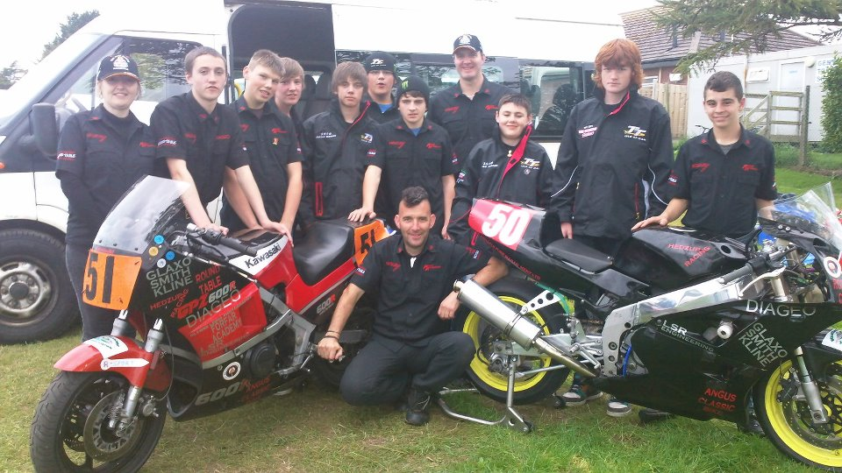
Special Guests - Hedzup Racing

