|  |
| --- |
| Banchory Signage Project |
| Public Consultation Results  9/1/2017 |

Macintosh HD:Users:lgourley:Desktop:Aberdeenshire Council Templates:A4 Report:Aberdeenshire_Council_Brand_Refresh_A4_Report Folder:Aberdeenshire_Council_Brand_Refresh_A4_Report_background.pdf

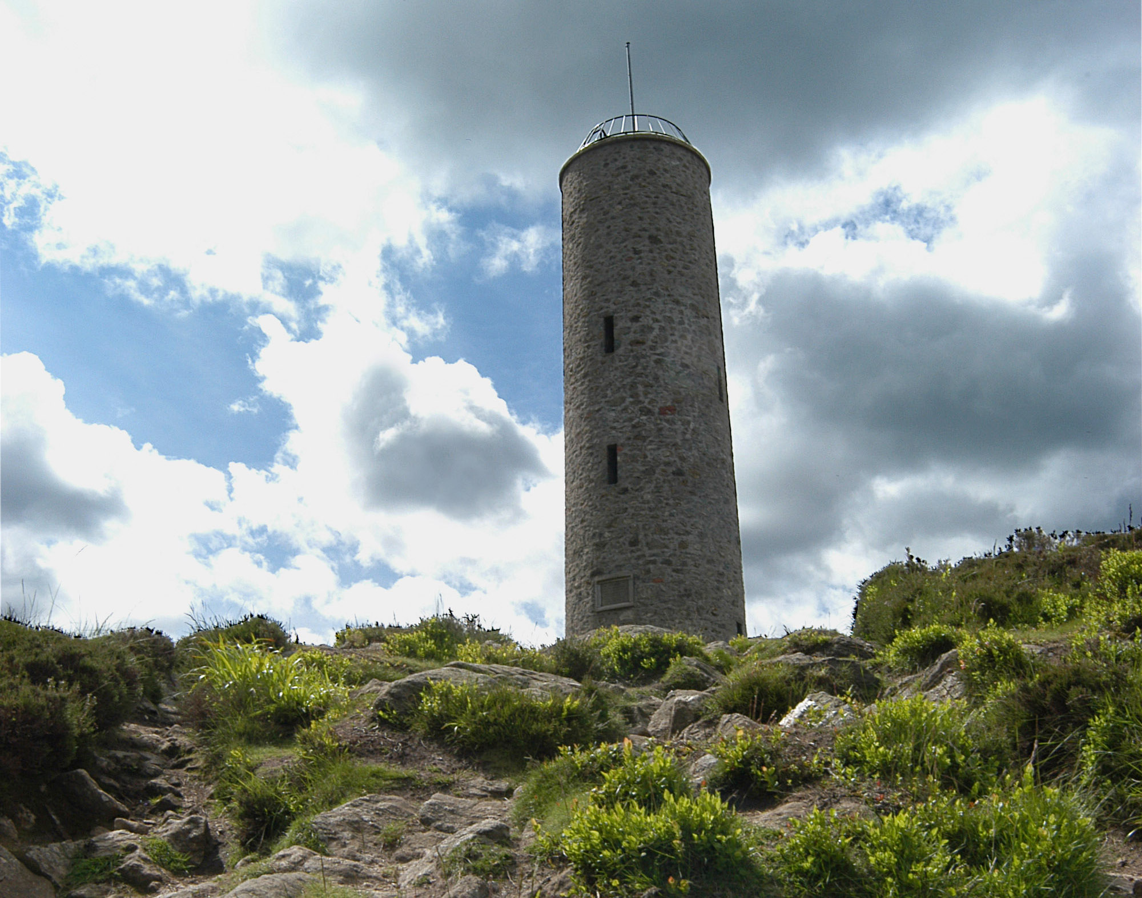

Contents

[1. Introduction 3](#_Toc472595391)

[2. Summary of Consultation Results 3](#_Toc472595392)

[3. Methodology 4](#_Toc472595393)

[4. Complete results 5](#_Toc472595394)

[Finger posts 5](#_Toc472595395)

[Information Boards 7](#_Toc472595396)

[Proposed Vehicle signs 10](#_Toc472595397)

[Gateway signs 12](#_Toc472595398)

[Scott Skinner Square 14](#_Toc472595399)

[Benches 15](#_Toc472595400)

[5. Additional comments and responses/proposed actions 18](#_Toc472595401)

[6. Comments from consultation groups 25](#_Toc472595402)

[7. Project Delivery Schedule 26](#_Toc472595403)

[8. Further information for the Town Team; comments from consultation not related to project. 27](#_Toc472595404)

# Introduction

Following the local Town Team’s approval of draft recommendations to improve signage in Banchory, the suggested improvements were put to public consultation from 18th November to 2nd December.

# Summary of Consultation Results

* Locations (97.62%) and destinations (91.89%) for the vehicle signs are appropriate
* The street name plates relating to Scott Skinner Square (Smiddy Wynd and Postie’s Walk) should be the same colours as the finger posts. (93.88%)
* Locations of the fingerposts are appropriate. (93.48%)
* Respondents agreed with the recommendation to erect a 3 sided, upright, sheltered structure as the main information feature in town located in **Bellfield Car Park**. (91.84%)
* Respondents think incorporating an image representative of Banchory on the gateway signs is a good idea. (91.11%)
* Respondents agreed with the recommended locations, styles and contents of the proposed information boards (86.67%)
* The bench outside RBS should be replaced with an information board; re: High Street history (86.36%)
* Finger post destinations are appropriate (86.05%)
* New benches should be constructed of black recycled plastic (77.27%)
* Retain the existing black/gold design for the fingerposts (65.96%)
* The bench outside the library should be replaced in a similar style to the street furniture in Scot Skinner Square. (64.44%)

There were no clear majority preferences for the following subjects:

* Information board in Scott Skinner Square: A Single wall-mounted board (53.33%) VS upright back to back board outside Library (46.67%).
* 55.1% believe the archway above the entrance to Scott Skinner Square needs refreshed/updated and 44.9% believe it should remain as it is.
* There was no favoured location for the information board in Bellfield Car Park:

A landscaped area currently occupied by the raised flower bed next to the Doctor’s Surgery (36.17%)

Next to the Pay & Display machine (34.04%)

On the pavement area near the entrance to the car park (29.79%)

* The suggested images that were mentioned the most for use on gateway signs were
  + Scolty Tower (mentioned 24 times)
  + Falls of Feugh (mentioned 10 times)
  + River Dee (mentioned 7 times)
* Many comments suggested that a competition take place to decide the final image for the gateway signs.
* Comments suggested “Gateway to Royal Deeside” is an already established tagline, more favourable than “The Place to Be” for Banchory and should be included on the gateway sign.

# Methodology

The consultation had both a physical and online presence. A physical display was located at Banchory library. The display, with accompanying feedback forms, featured maps showing where signs, street furniture and information boards are located in the town centre and the proposed changes to each.

Council officers attended the display at the library on two separate occasions to answer questions about the project. An equivalent survey and maps in PDF format were made available online at the *VisitBanchory* website.

There were **57** total responses; 4 online and 53 were completed in person at the display library or in their own time. Not all respondents answered every question. The majority of respondents were residents (95.29%).

The consultation was promoted on social media, the VisitBanchory website, local press, radio and physically handing out flyers at the Farmer’s Market; the flyer featured the dates, location of the consultation and when council officers would be in attendance to take questions. An electronic version of this was also available for partners and stakeholders to circulate.

Direct feedback was obtained from the following consultation groups by council officers:

* Banchory Business Association
* Banchory & District Initiative
* Banchory Paths Association
* Older People’s Forum
* Royal National Institute for the Blind
* The Scolty Centre

And the following groups were contacted for comments:

* Community Council
* Dementia Friendly Communities c/o Aberdeenshire Voluntary Action

Further comments from a questionnaire and public event held in support of the Community Action Plan are included later in this report.

The elements of this consultation were carried out in accordance with Aberdeenshire Council’s consultation Code of Practice and Toolkit.

# Complete results

## Finger posts

*Q1: Which is your preferred design for the finger posts?*

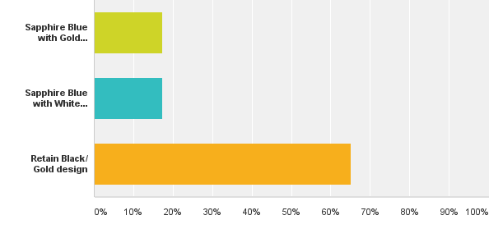

Sapphire with Gold details 17.02%

Sapphire with White details 17.02%

Retain Black/ Gold design 65.96%

Sapphire Blue with gold details 16.67%

Sapphire Blue with White details 18.75%

Retain Black/ Gold design 64.58%

Answered: 47 Skipped: 9

*Q2: Do you think the locations of the finger posts are appropriate?*

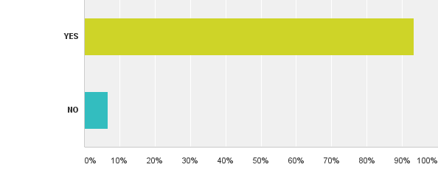

YES 93.48% NO 6.52%

Answered: 46 Skipped: 10

Additional Comments:

|  |
| --- |
| Extra one required at traffic lights High Street/Dee Street |
| in keeping with other Deeside villages and avoids unnecessary replacement |
| A bit old fashioned and not easy to read. |
| I would have preferred light blue |
| Additional posts at Kinneskie Road end of town may be useful |

*Q3. Do you think the destinations on the fingerpost are appropriate?*

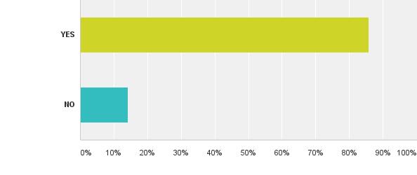

YES 86.05% NO 13.95%

Answered: 43 Skipped: 13

Additional comments:

|  |
| --- |
| Fingerpost signage in KGV park car parking area pointing to toilets etc. |
| Signage in car park of football pitches pointing to toilets, Milton of Crathes etc. |
| Retain consistency across entrances and types of furniture. Black/ gold is much more traditional than blue/yellow and is in keeping with the nature of the village. |
| Perhaps a fingerpost from the parking area at King George V park pointing to Town Centre, Toilets, Car Park, Doctors etc. |
| Need to be distinctive |
| More information pointing to walks, points of interest is necessary |
| 2,5; 1,6 seem to be close together and confusing given different destinations. |
| Need to be careful at entrance to Scott Skinner Square as this is vehicular access. |
| Finger posts too high as people's eyes are drawn to library and therefore they miss the signs. Countless people come to the edge of the steps and turn back |
| Additional signs for Visit Scotland upon entering village at 4 entrances |
| 7(2) South - Deeside Way 6(1) South - Deeside Way |
| Designs, very traditional and in my professional opinion do not improve directional flow of people. Colours are not best for attracting attention. |
| Suggest extra fingerpost from Deeside Way to Kirkyard |
| Recreation grounds would be better signed as Bowls, Tennis, Putting |
| PLEASED TO SEE THAT THERE IS NO MENTION OF KINCARDINESHIRE WHICH SHOULD BE DELETED FROM EVERYTHING NORTH OF STONEHAVEN |
| Larger type for poor sighted people would be beneficial. Ask partially sighted people to test colours for signage. |
| Size of the lettering is important. Present ones are too small. |
| Good idea |
| Banchory bus stop interactive information - doesn't give the time. Disability logo on toilet sign. |
| No 2 too wordy. Too much duplication across signs 6,2,5,7. |
| 1 or 2 towards the Western end of town. |
| Banchory might attract visitors looking for their 'roots' so perhaps signposts to the grave yard might be appropriate. |
| Gold ball finial |
| Need signpost for West Dee Walk located at Bridge |
| There should be clearer signs at the end of the road into the Scolty centre so that people can find it more easily |
| Consider signage to CAB and CLAN. Neighbouring charities used by public, both local & from further afield, and based in Posties' Wynd. |
| 3. Could show more walks and destinations. |

## Information Boards

*Q4. Do you agree with the recommended locations, styles and contents of the proposed information boards?*

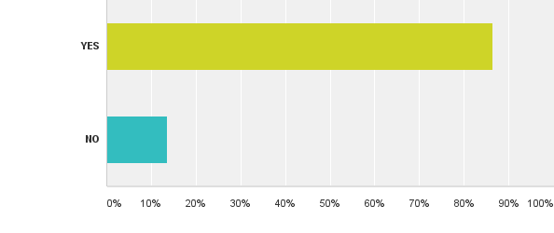

Answered: 46 Skipped: 9

YES 86.67% NO 13.33%

Answered: 45 Skipped: 11

Additional comments on designs, locations and contents:

|  |
| --- |
| Information board for KGV park area identifying way for the Crathes Castle/ Milton of Crathes showing mileage. |
| As above showing mileage to Milton of Crathes/ Crathes castle. |
| Not sure |
| KGV park signage - "Town Centre, Toilets (perhaps fingerposts would be enough?) etc. also identifying the Deeside Way to Milton of Crathes. |
| We need fewer signs not more |
| They must be clear, give good information and include “What’s On" possibility which can be changed regularly. |
| Disagree with the removal of the Community noticeboard at the Town Hall. Can the condensation problem not be remedied? Air vents? Silica gel contained at base and changed occasionally? |
| I think a bit confusing |
| Possible for RBS seat remain and signboard compliment the bench? |
| Board in churchyard a disgrace also one near Dee Bridge needs attention |
| feel the boards need to be more noticeable |
| CONTENTS NEED TO BE REPLENISHED WHEN THEY FADE. WOULD BE BETTER IF IN A MORE PERMANENT MATERIAL THAT WOULD BE LESS LIABLE TO FADE. |
| Bus stop interchange should have large sized map so ALL can read it and be a map that indicated walking routes (as in current Positive Steps maps) |
| Like the sloping information boards and also the idea of them being on stones. |
| Keep board design standard. |
| But we do need "notice" boards for events etc. at least 1 maybe 2. |
| [Toilets?] and shops in Bellfield Car park. |
| Don’t remove town hall noticeboard. It's only one that can be used by the public. Replace it if possible. |
| Boards marked 9,10,11; clear trees to give a view to the river! Town Hall notice board. A general information 'What's going on?' board needed for the town. ? new location? |
| Please ensure historical accuracy of the information boards. Some of the existing ones are not suitable for visitors. |
| Consider adding: Notice of Banchory West Church (public) Friday Coffee Morning (just celebrated 30years!). Only normally cancelled if it falls on Xmas/New Year’s Day! For community & funds raised support local charities. (Contact: Administrator (Jill Smith), BTWC 01330 822006 or office@banchorywestchurch.com |

*Q5. Which of the following options would be best for an Information board in Scott Skinner Square?*

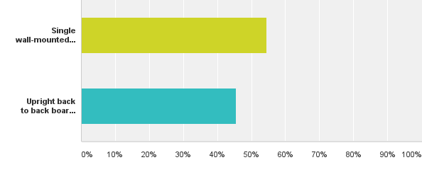

Single wall mounted information board 53.33%

Upright back to back board attached to a finger post near the entrance to the library. 46.67%

Answered: 45 Skipped: 11

*Q6. Do you agree with the recommendation to erect a 3 sided, upright, sheltered structure as the main information feature in town located in* ***Bellfield Car Park****?*

*This would include 1 Map + 1 Interpretation board + 1 Community noticeboard.*

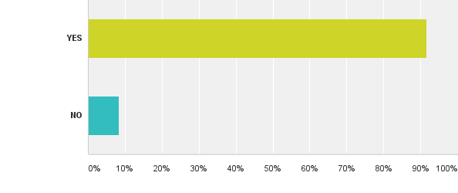

YES 91.84% NO 8.16%

Answered: 49 Skipped: 7

Additional comments:

|  |
| --- |
| The car park is ugly and why not direct people to Scott Skinner Square. Making it more of a hub for information. |
| Why the car park? If ???? then repeat at Town Hall. |
| Sheltered central point for visitors is essential. |
| Very good idea. Another would be good at Scott Skinner Square as we are wanting this to be a centre. |
| In an attractive landscaped area; most central to street and Car park |
| Should be 6 sides instead of 3 sides |
| Why can’t wall of old public convenience be used for the boards. |
| will become a hangout for kids |
| Good that it is sheltered |
| Location is important and needs to be easily accessible by ALL abilities. |
| Great idea. |
| Yes we need a structure but not too big just cover to protect readers when reading boards. |
| A similar 3 sided board as proposed at Bellfield Car Park to also be in Scott Skinner Square. |

*Q7. Where do you think this feature should be installed in Bellfield Car Park?*

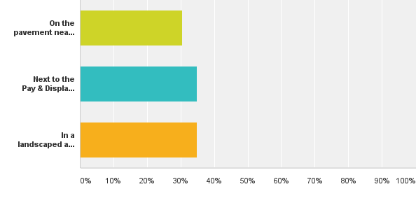

On the pavement area near the entrance to the car park and cycle racks 29.79%

Next to Pay & Display machine 34.04%

In a landscaped area currently occupied by the raised flower bed closest to Doctor’s Surgery. 36.17%

Answered: 47 Skipped: 9

## Proposed Vehicle signs

*Q8. Do you think the locations of the signs are appropriate?*

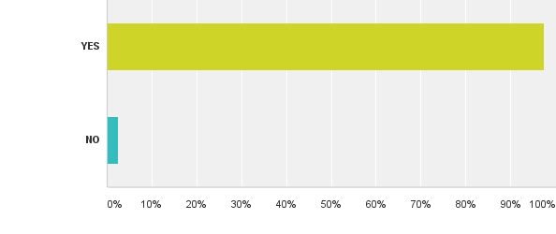

YES 97.62% NO 2.38%

Answered: 42 Skipped: 14

*Q9. Do you think the destinations on the signs are appropriate?*



YES 91.89% NO 8.11%

Answered: 37 Skipped: 19

Additional comments:

|  |
| --- |
| Don't know |
| The locus at the P&D machine may require losing a couple of parking spaces but the car park is never full anyway. |
| too many signs too late for folk to act on |
| No signage for Scolty/ Walks; No signage for Inchmarlo Golf Club/ Tennis/ Bowling Club |
| Destinations should give current destinations and places of interest. |
| Crathes Castle, Scolty Car Park - Something tourists would probably look for. |
| Include putting bowling club and tennis courts on signs. |
| Make signs more identifiable to Banchory. Create a unique design rather than road signs. |
| FOR ENTRY INTO BANCHORY FROM EAST, NORTH, SOUTH "WELCOME TO BANCHORY" "GATEWAY TO ROYAL DEESIDE" FOR EXIT FROM BANCHORY "THANK YOU, SAFE JOURNEY" |
| Remove current Advice Centre sign info re SWCAB (Citizen's Advice) |

## Gateway signs

*Q10. Do you think that incorporating an image representative of Banchory on the gateway signs is a good idea?*

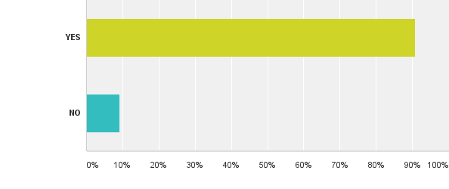

YES 91.11% NO 8.89%

Answered: 45 Skipped: 11

*Q11. Which image(s) should be used? Something significant to Banchory e.g. Scolty Tower, Falls of Feugh, Dee Lavender.*

SCOLTY TOWER mentioned 24 times.

Falls of Feugh mentioned 9 times.

River Dee mentioned 7 times.

Answered: 45 Skipped: 11

Additional comments:

|  |
| --- |
| Scolty Tower Falls of Feugh |
| Local attraction is Scolty Hill, River Dee etc. - Local artists’ competition? |
| Falls of Feugh |
| Don't know - it depends on the image as it will only be effective as a visual reminder if it is also replicated by other in their leaflets/ literature. Someone also suggested a school competition. This could be offered as a prize/ competition to senior art students and would encourage participation, partnership working and community indecision. |
| River Dee - perhaps a competition among local amateur artists - could include the paintings on local postcards maps etc. |
| Falls of Feugh |
| River Dee |
| Falls of Feugh |
| Scolty Tower or Scott Skinner fiddle/ Music |
| Scolty Tower |
| Image of Banchory or Scolty Tower. It should also incorporate “Gateway to Royal Deeside" on the access from East, North and South. |
| Scolty Tower |
| Scolty Tower |
| Gateway signs need separate consideration. Inchmarlo Road is OK (lost in trees though). No signs from Strachan approach. Need relocating as Tesco end to the 40mph signs - nearer to the Rotary Banchory Stone. |
| Scolty Tower |
| Landscape shot; When I think of Banchory I think of the hills and topography and the river. |
| Scolty Tower |
| SCOLTY TOWER |
| Falls of Feugh, River Dee |
| ~Scolty tower |
| All of them. Make them different on each sign. Make design unique to Banchory not a traditional road sign. |
| IMAGES FOR THE RIVER DEE WHERE THE FEUGH JOINS IT |
| Personally a salmon, but suggest ask local artists to compete and offer a prize |
| Scolty Tower |
| Scolty Tower |
| River Dee |
| Falls of Feugh |
| Falls of Feugh + Scolty Tower, modern style. Not Dee Lavender. |
| Probably the Tower, or maybe a combination of the Tower and the Falls of Feugh or all three! |
| Scolty Hill |
| Scolty tower. |
| Scolty tower + folk on bikes to emphasise activity. Maybe leaping salmon. |
| St Ternan |
| Scolty tower, Dee Lavender |
| Falls of Feugh/ River Dee and surroundings. |
| I like the existing Rotary Club stones at end of the town. |
| SCOLTY TOWER |
| Violin for Scott Skinner |
| Scolty tower (entry point from Aboyne); Dee lavender (entry point from North Deeside Road); red squirrel (entry point from Raemoir) |
| Scotty Tower |
| Scolty Tower |
| No strong feelings but Scolty Hill & Tower would seem obvious landmark if an image is to be used |
| Scolty Tower, Falls of Feugh |

## Scott Skinner Square

*Q12. Does the Archway sign above the entrance to Scott Skinner Square need updated/ refreshed?*

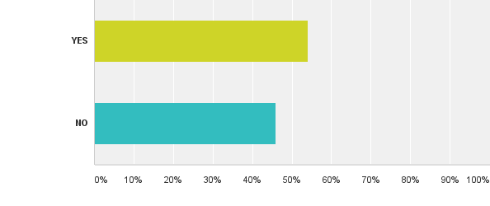

YES 55.10% NO 44.90%

Answered: 49 Skipped: 7

Additional comments:

|  |
| --- |
| Arch is in the wrong location. Not visible from the pavement. Identities should be on walls to attract passing traffic. |
| But only if spectacular enamel/ ironwork...worth looking at for more than seconds. |
| Image of Scott Skinner |
| refreshed |

*Q13. Do you think the street name plates relating to Scott Skinner Square (Scott Skinner Square, Shops, Smiddy Wynd, Postie’s Walk) should be the same colours as the finger posts?*

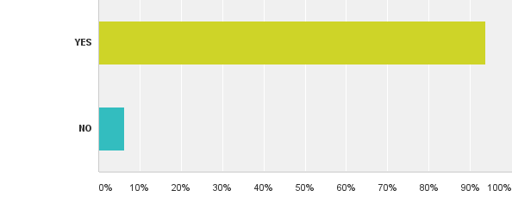

YES 93.88% NO 6.12%

Answered: 49 Skipped: 7

## Benches

*Q14. What should happen to the bench outside the library?*

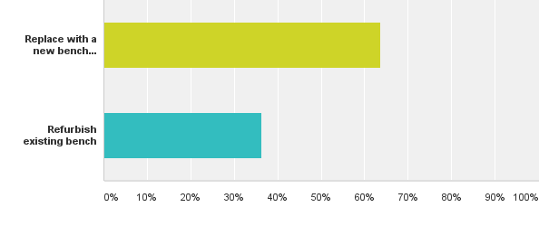

Replaced with a new bench similar in style to the other benches in Scott Skinner Square? 64.44%

Refurbish existing bench 35.56%

Answered: 45 Skipped: 11

*Q15. Should any new benches be constructed of black recycled plastic (like current benches on High Street)?*

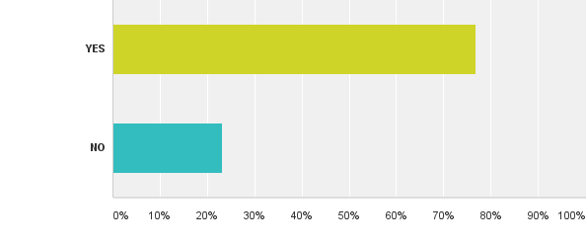

YES 77.27% NO 22.73%

Answered: 44 Skipped: 12

*Q16. Do you agree that the bench outside RBS should be replaced with an information board (providing information about the High Street, history and orientation to visitors)?*

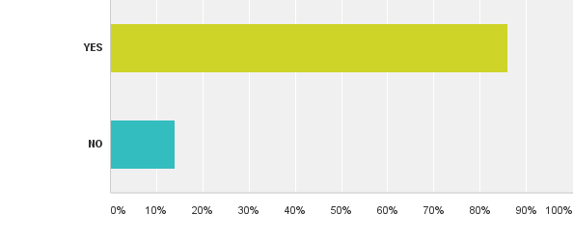

YES 86.36% NO 13.64%

Answered: 44 Skipped: 12

*Q17. Please use this space to leave any further comments on the other recommendations shown*.

|  |
| --- |
| Consider planting trees on pavement north side of high street |
| No notification regarding disabled access |
| All new sings, replacements should be of the same colour and design using Banchory Logo/colours |
| Scott Skinner Square needs map or explanation of flats and shops as emergency/ delivery drivers etc. I have difficulty locating appropriate places. |
| Signs should be as large as possible. |
| BENCH OUTSIDE LIBRARY SHOULD BE MADE OF BLACK RECYCLED PLASTIC - RESIDENT / BUSINESS OWNER |
| I do not see Tillybrake Field included in your plan but suggest provision of signs addressing dog fouling be incorporated and placed in prominent positions. |
| What is the point of all this when the shops are empty and there is nothing for visitors anyway - Resident and business owner |
| Map F Q3. A replacement bench needs to be added. Cycle parking - Add hoops onto lampposts to encourage cycle parking in the High Street and generally provide more cycle parking in the centre. |
| Would like to see network of (rails?) around the village and surrounding area that could be incorporated into the boards and signage. - Sign owner |
| Better calming measures in the Bellfield Car Park to attempt to prevent the endless nightly noise from mindless "boy racers" CCTV with number plate recognition well signed might dissuade them, from, say, 19:00 until dawn. |
| BLOCK OF ENTRANCE TO SCOTT SKINNER SQUARE AND BAN ALL CARS FROM SCOTT SKINNER SQUARE APPROACHES SUCH AS OUTSIDE REPROGRAPHICS SHOP. |
| Hopefully people with disabilities will respond to give you a feedback from their respective. |
| Tactile pad placed at corner of Dee Street/ Bridge Street to assist the visually impaired. Bollard beside it for them to walk into?! |
| It's hard to know what is significant - Scolty is the obvious one but might not be such a good subject. |
| Bench outside RBS should be replaced but only if there is only one main board in the car park. |
| Sign at the foot of the lane. The Royal British Legion at St Ternan Place is on the wall of the house so would a sign saying St Ternan Place. Some people think that it's coming into Banchory. |
| No place to comment on maps G,I or J. |
| Map G - Please put bin at the bus stop nearest the undertakers. -Add another bin between the bike shop and secondary school if possible. -Bin near Raemoir Lane/ Raemoir Road (Dalvenie Centre). Litter dropped between school and Tillybrake shop. Bin in car park area near netball pitch at the school side of Scolty Centre. Littering in these areas. |
| No plastic - think of the environment. Please use wood. |
| No feeling |
| There is not a sign that says “Shaw’s Court 14-17”. I have been asking for one for 5 years. G-Docs visited on Saturday evening and guess what he could not find Shaw's Court. I don’t care what sign looks like just put one up ASAP. |
| Consider planting trees along High street on North side |

*Q18. What brings you to Banchory?*

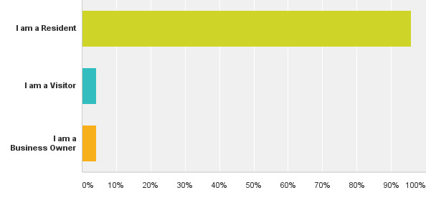

Residents 94%

Visitors 4%

Business Owners 6%

Answered: 50 Skipped: 6

# Additional comments and responses/proposed actions

| **Theme** | **Respondents in their own words** | **Recommended for action/ consideration** | **Action/ Rationale** |
| --- | --- | --- | --- |
| Finger posts  Finger posts  (continued) | Extra one required at traffic lights High Street/Dee Street | ✔ | **This will be installed.** |
| Additional posts at Kinneskie Road end of town may be useful | X | The proposed Orientation board in Bridge Street Car Park will provide this information. |
| Fingerpost signage in KGV park car parking area pointing to toilets etc. | ✔ | Fingerpost 7 on Dee Street provides this information to those exiting King George V park. Consideration will be given to this. Doctor’s Surgery/ private business is not recommended for signing.  This finger post will include arms pointing to Toilets, Tourist information and the car park for those returning from the Deeside Way.  **This is to be installed.** |
| Signage in car park of football pitches pointing to toilets, Milton of Crathes etc. |
| Perhaps a fingerpost from the parking area at King George V park pointing to Town Centre, Toilets, Car Park, Doctors etc. |
| More information pointing to walks, points of interest is necessary | ✔ | **Recommendations include an increase in tourist destinations featured on finger posts.**  Forthcoming review of walking/cycling signage as part of Integrated Travel Town project. |
| 2,5; 1,6 seem to be close together and confusing given different destinations. | X | The posts work together as a network, 5 leads to 7 if coming from Bridge Street (having already passed 3) travelling South. |
| Finger posts too high as people's eyes are drawn to library and therefore they miss the signs. Countless people come to the edge of the steps and turn back | X | Fingerposts must be at regulated height. |
| Designs, very traditional and in my professional opinion do not improve directional flow of people. Colours are not best for attracting attention. | X | Colour scheme based on Banchory palette. |
| Suggest extra fingerpost from Deeside Way to Kirkyard | ✔ | **A wooden fingerpost will be placed here.** |
| Larger type for poor sighted people would be beneficial. Ask partially sighted people to test colours for signage. | ✔ | Regulation letter size deemed visible by RNIB consultant. Comments received re: colour contrasts. |
| Size of the lettering is important. Present ones are too small. |
| No 2 too wordy. Too much duplication across signs 6,2,5,7. | X | ‘Duplicated’ destinations are for those entering town from different directions. From West - Bus Stops;  from South West - Bridge Street Car Park; from East - Bellfield Car Park. |
| 1 or 2 towards the Western end of town. | X | The proposed orientation board at Bridge Street Car Park will provide information for those beginning their journey from the West after travelling independently.  Those who have arrived by public transport will see the natural flow towards the High Street. |
| Banchory might attract visitors looking for their 'roots' so perhaps signposts to the grave yard might be appropriate. | ✔ | **The kirk yard will be signposted on the Deeside Way finger posts** and included on orientation boards at car parks. |
| Need signpost for West Deeside Walk located at Bridge | X | This was considered however objected by the Golf club. |
| Consider signage to CAB and CLAN. Neighbouring charities used by public, both local & from further afield, and based in Posties' Wynd. | X | **Signage for these organisations will not be provided through this project.** |
| Disability logo on sign. | ✔ | **A disabled logo will be added to any fingerposts directing to ‘TOILETS’.** |
| Information Boards | Information board for KGV park area identifying way for the Crathes Castle/ Milton of Crathes showing mileage. | X | Not recommended. Bellfield orientation panel would include this information. |
| As above showing mileage to Milton of Crathes/ Crathes castle. | ✔ | **Crathes Castle is to be included on finger posts.** |
| They must be clear, give good information and include “What’s On" possibility which can be changed regularly. | ✔ | **Proposed information board in Bellfield Car Park will include main community notice board.** |
| Disagree with the removal of the Community noticeboard at the Town Hall. Can the condensation problem not be remedied? Air vents? Silica gel contained at base and changed occasionally? | ✔ | **Following discussion the Community Noticeboard is to be replaced. Relocation to North Side of Street to be considered.** |
| Don’t remove town hall noticeboard. It's only one that can be used by the public. Replace it if possible. |
| Possible for RBS seat remain and signboard compliment the bench? | X | Not recommended. Appearance may be cluttered and distract from prominence of the board. |
| Board in churchyard a disgrace also one near Dee Bridge needs attention | ✔ | **This is being replaced by the Historic Asset Management Project.** |
| CONTENTS NEED TO BE REPLENISHED WHEN THEY FADE. WOULD BE BETTER IF IN A MORE PERMANENT MATERIAL THAT WOULD BE LESS LIABLE TO FADE. | ✔ | New board materials to be explored with manufacturers at design stage. |
| Bus stop interchange should have large sized map so ALL can read it and be a map that indicated walking routes (as in current Positive Steps maps) | ✔ | Interactivity potential is being explored with Public transport. Printed maps to be installed in shelters also. |
| Keep board design standard. | ✔ | **One artist will ensure consistent design of all boards.** |
| Boards marked 9,10,11; clear trees to give a view to the river! Town Hall notice board. A general information 'What's going on?' board needed for the town. ? new location? | ✔ | **Ongoing maintenance of this area is being investigated by the area office. Bellfield board proposed as central information point.** |
| Consider adding: Notice of Banchory West Church (public) Friday Coffee Morning (just celebrated 30years!). Only normally cancelled if it falls on Xmas/New Year’s Day! For community & funds raised support local charities. | ✔ | **A notice can be permanently displayed in the Community noticeboards.** |
| 3 sided information board, Bellfield Car Park | The car park is ugly and why not direct people to Scott Skinner Square. Making it more of a hub for information. | ✔ | Bellfield Car Park is the natural origin point for people who visit Banchory by car. It has the most car parking spaces and is located next to the High Street (access to shops) and Dee Street (access to Scolty Hill & Falls of Feugh). Facilities also include Public Toilets and Coach parking.  **This is to be the location for the structure. An additional 3 sided board at Scott Skinner Square will be costed to aid consideration.** |
| Very good idea. Another would be good at Scott Skinner Square as we are wanting this to be a centre. |
| A similar 3 sided board as proposed at Bellfield Car Park to also be in Scott Skinner Square. |
| Should be 6 sides instead of 3 sides | X | Minimum of 3 panels required including general information, orientation and community events/information. Additional panels would be unnecessary.. |
| Why can’t wall of old public convenience be used for the boards. | X | The proposal is that the board be located at a central point visible from all areas of the car park, not blending into a wall. |
| will become a hangout for kids | X | Will not be a structure (like huts in Bellfield Park) which can accommodate people. |
| Location is important and needs to be easily accessible by ALL abilities. | ✔ | **Will be accessible to all.** |
| Vehicle Signs | The location at the P&D machine may require losing a couple of parking spaces but the car park is never full anyway. | X | These are high turnover, high demand spaces which are used to access the GP practice. This is no longer an option following feedback from car parks staff. |
| No signage for Scolty/ Walks; No signage for Inchmarlo Golf Club/ Tennis/ Bowling Club | ✔ | **Scolty Hill will be signed on finger posts and vehicle signs** at decision points. Inchmarlo golf club is already signed. |
| Include putting bowling club and tennis courts on signs. | X | **This is covered by ‘Recreation Grounds’.** |
| Crathes Castle, Scolty Car Park - Something tourists would probably look for. | X | Including these locations would require the loss of existing destinations. Adding more creates the clutter or ‘mounted signage’ which this project aims to prevent. |
| Make signs more identifiable to Banchory. Create a unique design rather than road signs. | X | The majority of vehicle signs are regulated and cannot be customised. The proposed gateway signs incorporate imagery specific to Banchory. |
|  |  |  |
| Remove current Advice Centre sign info re SWCAB (Citizen's Advice) | ✔ | **This will be removed.** |
| There should be clearer signs at the end of the road into the Scolty centre so that people can find it more easily | X | The Scolty Centre is out with the immediate study area of the town centre. |
| Gateway signs | FOR ENTRY INTO BANCHORY FROM EAST, NORTH, SOUTH "WELCOME TO BANCHORY" "GATEWAY TO ROYAL DEESIDE" FOR EXIT FROM BANCHORY "THANK YOU, SAFE JOURNEY" | ✔ | Designs pending until a consensus is reached on design and ownership of Banchory heraldry. |
| Additional signs for Visit Scotland upon entering village at 4 entrances | ✔ |
| Don't know - it depends on the image as it will only be effective as a visual reminder if it is also replicated by other in their leaflets/ literature. Someone also suggested a school competition. This could be offered as a prize/ competition to senior art students and would encourage participation, partnership working and community indecision. | ✔ | A competition element will be held. |
| Perhaps a local competition among local amateur artists – could include the paintings on local postcards maps etc. |
| River Dee - perhaps a competition among local amateur artists - could include the paintings on local postcards maps etc. | ✔ |
| Miscellaneous | Sign at the foot of the lane. The Royal British Legion at St Ternan Place is on the wall of the house so would a sign saying St Ternan Place. Some people think that it's coming into Banchory. | X | The Royal British Legion is signed from the High Street and is just out with the town centre study area. |
| Scott Skinner Square needs map or explanation of flats and shops as emergency/ delivery drivers etc. I have difficulty locating appropriate places. | X | Recommendation to install sign for Shaw’s Court but no plans for a map. |
| Signs should be as large as possible. | X | Signs must be of a regulated size. |
| Map F Q3. A replacement bench needs to be added. Cycle parking - Add hoops onto lampposts to encourage cycle parking in the High Street and generally provide more cycle parking in the centre. | X | There is cycle parking in the centre at the car park and at the library. Project is aiming to remove clutter of street furniture. |
| No plastic - think of the environment. Please use wood. | X | Benches made of recycled plastic has been recommended as comparably more environmentally friendly than wood. |
| There is not a sign that says “Shaw’s Court 14-17”. I have been asking for one for 5 years. G-Docs visited on Saturday evening and guess what he could not find Shaw's Court. I don’t care what sign looks like just put one up ASAP. | ✔ | **This has been installed.** |

# Comments from consultation groups

Feedback from Rhona Lewsey, Royal National Institute for the Blind, December 2016.

* Blue/ White finger post design is best contrast
* A-boards are hazardous – canes go under them and they clutter the footway.
* If A-board extends to the ground its OK – less problematic. (This is the same for information boards).
* Text height for finger posts is suitable.
* Bollards should have colour contrasting bands – white on black
* Uniformed positioning of street furniture
* Those with visual impairments are likely to walk on the building side of the pavement – position street furniture kerb-side.

Comments from Community Action Plan public event, September 2016.

* Better signage – toilets, putting green etc.
* Existing Banchory Logo is poor design, needs to be re-thought – perhaps more traditional
* Signage for Tourist Office is not accurate – either traffic signs on the High St and pedestrian sign outside Bellfield Carpark
* Dog walking places are just disappearing and walking dogs around streets is not where dogs should be walked constantly on a lead. Need space back and decent paths for this, with signage for same
* Those signs that are about are not pointing in the correct position
* Banchory Brand needs to be used more effectively throughout the town in terms of welcome signage, wayfinding and ensure consistency
* Better signage and information throughout the village to identify areas i.e. Scott Skinner Square and also provide useful info and directions
* Signpost Banchory museum

# Project Delivery Schedule

Speculative timeline – subject to change following meeting with Project Officer.

|  |  |  |  |  |
| --- | --- | --- | --- | --- |
|  |  |  |  | **April &** |
| **Action** | **January** | **February** | **March** | **Beyond** |
| Consultation evaluation - redraft/amend proposals |  |  |  |  |
| Banchory Signage Implementation Group to assess Consultation results |  |  |  |  |
| Present specifications and indicative costings to Town Team |  |  |  |  |
| Final comments from Town Team |  |  |  |  |
| Prioritise proposals |  |  |  |  |
| Implementation Phases Agreed |  |  |  |  |
| Meet with Project Officer |  |  |  |  |
| DEADLINE 31/3/2017 |  |  |  |  |
| Planning and roads permissions |  |  |  |  |
| Working drawings, artwork & content |  |  |  |  |
| Production of signs |  |  |  |  |
| Procurement exercise |  |  |  |  |
| Installation |  |  |  |  |

# Further information for the Town Team; comments from consultation not related to project.

* Banchory bus stop information doesn’t give the time.
* Consider planting trees on pavement North of High Street
* Better calming measures in the Bellfield Car Park to attempt to prevent the endless nightly noise from mindless “Boy Racers”. CCTV with number plate recognition well signed might dissuade them, from, say, 19:00 until dawn.
* Block off entrance to Scott Skinner Square and ban all cars from Scott Skinner Square approaches such as outside reprographics shop.
* Tactile pad placed at corner of Dee Street/ Bridge Street to assist the visually impaired. Bollard beside it for them to walk into?!
* Please but bin at the bus stop nearest the undertakers. Add another bin between the bike shop and secondary school if possible. Bin near Raemoir Lane/ Raemoir Road (Dalvenie Centre). Litter dropped between school and Tillybrake shop. Bin [required?] in car park area near netball pitch at the school side of Scolty Centre. Littering in these areas.
* Dog walking places are just disappearing and walking dogs around streets is not where dogs should be walked constantly on a lead. Need space back and decent paths for this, with signage for same
* In what ways could MUSEUM be made better? Open oftener or better signposted for those looking for it